A COMPACT VLF ANTENNA OPTIMISED FOR 16 to 24kHz
(for reception of VLF stations and detection of SIDs)

Dr David Morgan

November 2010

- Introduction
The reception of VLF stations in the 16 to 24 kHz band is widely used for the detection of Sudden Ionospheric Disturbances (SID) that result from the impact of Solar X ray flares and other factors.

A wire loop antenna is commonly used as part of the VLF receiver and may consist of some tens to a hundred turns of wire on an open frame which may have a side length of around 30 to 100cm.

In this article a more compact antenna is discussed based on a conventional Ferrite Rod antenna widely used in domestic AM receivers. Two versions of the antenna are described, one is based on readily available AM radio ferrite rods that are usually 120mm long and can be obtained at low cost.

The second is an improved solution based on a larger ferrite rod, 200mm long and12mm diameter, with a purpose wound coil of Litz wire giving greater sensitivity at VLF.

This paper is set out in sections as follows:

2 VLF receiver requirements

3 Ferrite rod antenna (120mm)

- Purpose designed VLF ferrite rod antenna (200mm)

- Performance

- Digital Spectrum Analysis

- Using the system

- Conclusions

- VLF Receiver Requirements
The receiving system is made up of three parts:
- The Antenna
- The Amplifier
- The Filter / spectrum analyser

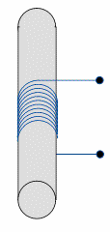

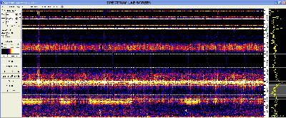
Ferrite
Rod
Antenna
40dB Gain
Differential
Amplifier
Computer
with sound card
Digital Spectrum Analysis
(Spectrum Lab)
Compact Multi Channel VLF Receiver

Figure 2.1 VLF Receiver Block Diagram

2.1 The Antenna
The antenna needs to be sensitive enough to produce a high signal-to-noise ratio with respect to the amplifier equivalent input noise.
It needs to be wide band, to cover the frequency range 16 to 24kHz.
In some circumstances it needs to be as compact as possible, especially if it is to be mounted out of doors where it is easier to make a small package waterproof and unobtrusive.

2.2 The Amplifier
This can be made from 2 or 3 operational amplifiers, with the first stage preferably constructed with a high input-impedance and low noise differential circuit. The overall gain needs to be in the region of 40 dB over the 16 to 24kHz bandwidth.

2.3 The Filter / Spectrum Analyser
Traditionally, physical electrical multi-pole filters using operational amplifiers have been used. Each filter is permanently tuned to the VLF station that is to be monitored and cannot be changed. The frequency spacing of the VLF stations is, in some cases, only a few hundred Hz and this requires the filters to be very narrow band. Consequently the filters can be rather complex and expensive, especially if multiple VLF stations are to be monitored simultaneously.
In this paper a multiple filter capability is implemented in software, enabling 10 or more stations to be monitored with equivalent filter bandwidths of around 10Hz. This is achieved with an excellent programme called Spectrum Lab www.qsl.net/dl4yhf/spectra1.html written by DL4YHF. It is freely available for non commercial use and is highly recommended.
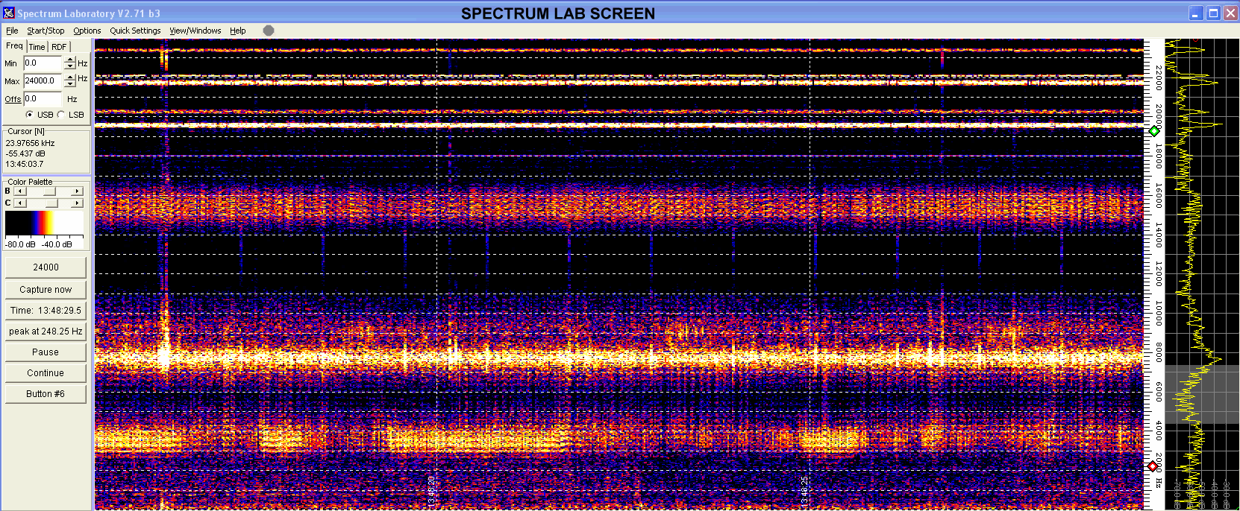

Figure 2.2 Spectrum Lab software (Waterfall plot window)

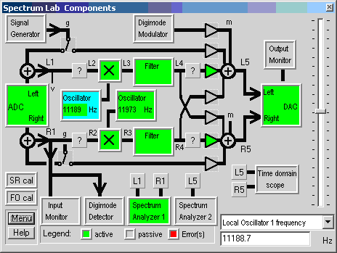

Figure 2.3 Spectrum Lab Software (Component window)

The Spectrum Lab software by DL4YHF is probably the most sophisticated analysis tool freely available, but any suitable programs can be used eg Spectrogram 16 or Spectran – both available on the internet.

- Ferrite Rod Antenna (120mm)
This well known form of antenna is widely used in LW and MW AM receivers and employs selected ferrite compositions with low loss over these frequencies. Typically the rods are 6mm diameter and 120mm long with small coils of Litz wire – one each for the LW and MW bands. See Figure 3.1.

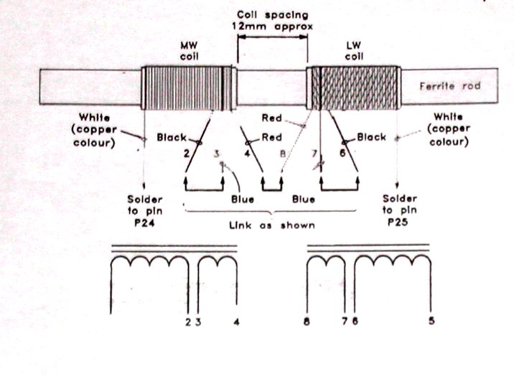


Figure 3.1 Readily available 120mm Ferrite Rod Antenna

The LW coil can be used on its own or all the coils can be connected in series (observing winding directions). Available from www.rapidonline.com .

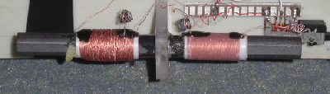

Figure 3.2 the Rapid 120mm Ferrite Rod Antenna

It is possible to use the LW coil and simply retune it with an external capacitor of between 0.01 and 0.001uF to bring its resonance below 100kHz and towards 10kHz. This configuration works reasonably well and VLF stations can be received with a signal-to-noise ratio of around 10 to 30dB above amplifier noise.

Typical VLF station frequencies can be seen in Figure 3.3 . These high signal-to-noise ratio results were obtained using a 1 square meter multi turn conventional loop antenna resulting in ratios as high as 50dB. Whilst such performance is not achieved with a small ferrite antenna, the signal-to-noise ratios are still useful for making observations.

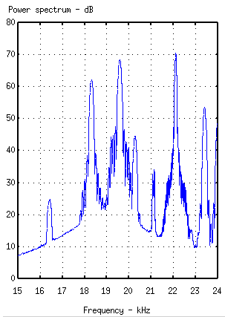

Figure 3.3.VLF Stations recorded with 1m² Loop Antenna

The performance that can be achieved with a standard 120mm ferrite rod is shown in Figure 3.4. The strength of the individual signals depends on the transmitter power, the distance to the transmitter and the orientation of the Ferrite antenna. In this case the orientation is optimised for reception of DHO from Germany on 23.4kHz.
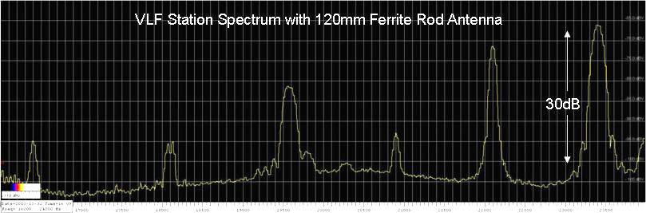
DHO

Figure 3.4 Spectrum from a 120mm Ferrite Antenna
with1nF external tuning capacitor on the LW coil
This performance is adequate for monitoring strong signals in the UK such as GBZ (16.9kHz), GQD (22.1kHz) and DHO (23.4kHz).

The amplifier circuit used with the 120mm ferrite antenna is shown in Figure 3.5. A single wide band high input impedance operational amplifier is used and the LW antenna coil is tuned with 1 nF low loss capacitor. This provides sufficient signal for connection to a computer sound card.

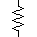
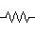
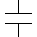
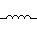
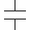
1.1M
1.1M
1uF Chip
cap
LW coil
MCP6023
3
2
6
7
4
output
+3v
0v
120mm
Ferrite Rod
10uF
47R
33
uF
1nF
On / Off
VLF Receiver with 120mm Ferrite Antenna

Figure 3.5 120mm Ferrite Antenna & Amplifier

SIDs can be detected with such an antenna as their amplitude may only change by 10dB over the normal received level. See Figure 3.6. However faithfully monitoring the full range of diurnal and seasonal variations in the levels of VLF transmitters requires a dynamic range of greater than 20dB.

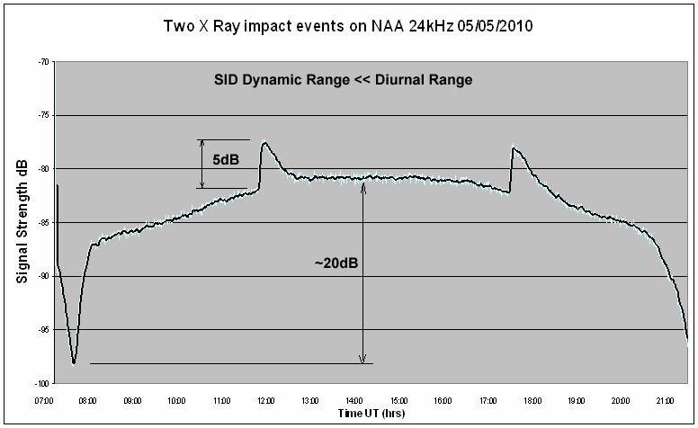

Figure 3.6 Typical change in received signal due to a SID
- Purpose designed VLF Ferrite Rod Antenna (200mm)
4.1 The sensitivity of a ferrite cored antenna can be significantly improved by the following changes:

- The choice of Ferrite material can be optimised for higher permeability at the expense of increased loss at higher LW frequencies – (that are not being received).
- The volume of ferrite can be increased by obtaining a longer rod with increased diameter.
- A coil with more turns than the traditional LW coil can be wound to increase the inductance, increase the received signal and partly self tune the antenna to VLF frequencies around 16 to 24kHz by increasing the coil self capacitance. A small external capacitor can still be used to optimise the tuning.

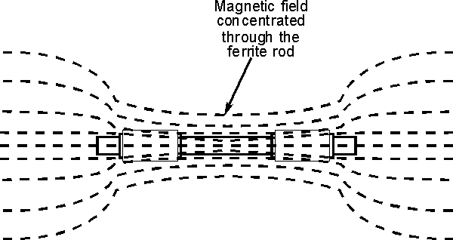

Figure 4.1 Flux concentration through a Ferrite Rod

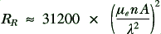
The sensitivity of an antenna is related to its radiation resistance, which is given by:

n = number of turns, A = area of turns, λ = wavelength
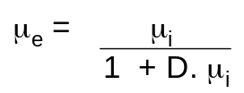
μ_{i} = the intrinsic permeability of the Ferrite, μ_{e}= the effective permeability of the rod
Now –

where D is a demagnetisation factor that depends principally on the length to diameter ratio of the rod.

In the example given in this paper the rod material is R33-050-750 obtainable from CWS ByteMark (+1 800-679-3184) - with a length of 200mm and a diameter of 12mm.

The details of the material used can be seen in Table 4.1 as marked with an arrow. This was chosen as a compromise between good LW/MW performance and some useful VLF response. For VLF work alone, the best material would have μ_{ι} = 2000 and 0.001 – 2 MHz frequency range
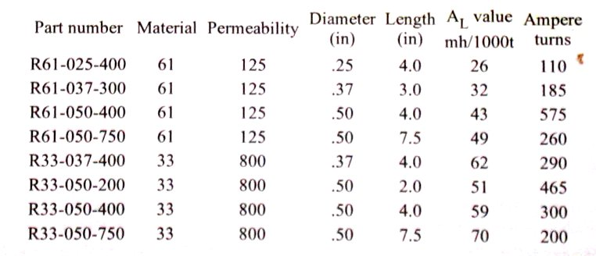

Table 4.1 Ferrite rod details

The specifics of the ferrite materials are given in Table 4.2.
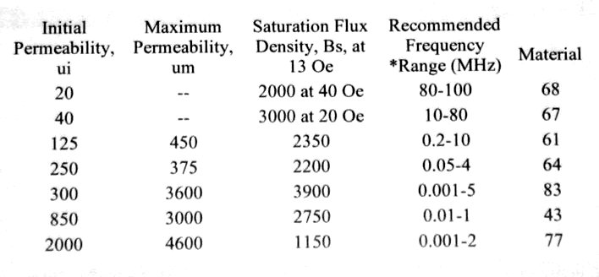

Table 4.2 Ferrite permeability figures

The coil is wound from 8/42 Litz wire with a few hundred turns giving the base coil an inductance of 3.02mH mH. The Inductance of the coil when located half way along the Ferrite rod is 42.5 mH The coil is scramble wound to minimise losses from inter-winding self capacitance. See Figure 4.2.

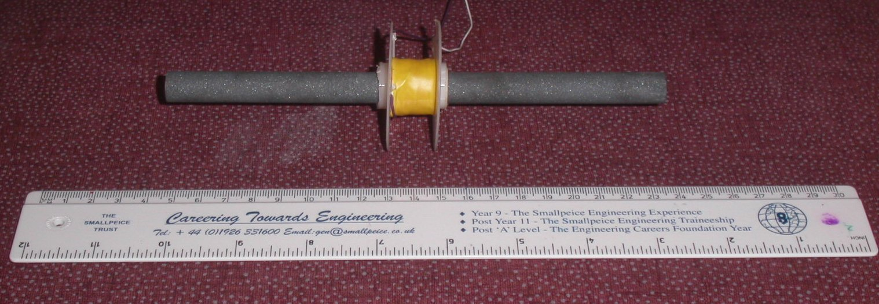

Figure 4.2 The 200mm Ferrite cored Antenna Coil
4.2 VLF Amplifier
A simple balanced-input high-impedance operational amplifier circuit with a gain of up to 40 dB was used in conjunction with this 200mm rod antenna.

The circuit shown in Figure 4.3 uses three stages. The first is a balanced high input impedance gain stage amplifier. The balanced configuration helps to minimise any common mode signal that may be picked up by the antenna coil and connecting cable. It is good practice to provide a copper foil screen around the coil with a slot cut in it to prevent a shorted turn. This can be connected to the ground in the circuit to prevent electric field pick up on the coil.

The second is a differential amplifier with a single output. This stage helps to eliminate common mode signals and leave only the genuine signal induced into the coil via the ferrite rod.

The differential amplifier feeds a narrow band twin T filter to help prevent any 50Hz mains signal from saturating further stages or the sound card in the computer.

This circuit is given only as a guide to what is required and many other amplifiers may be used.

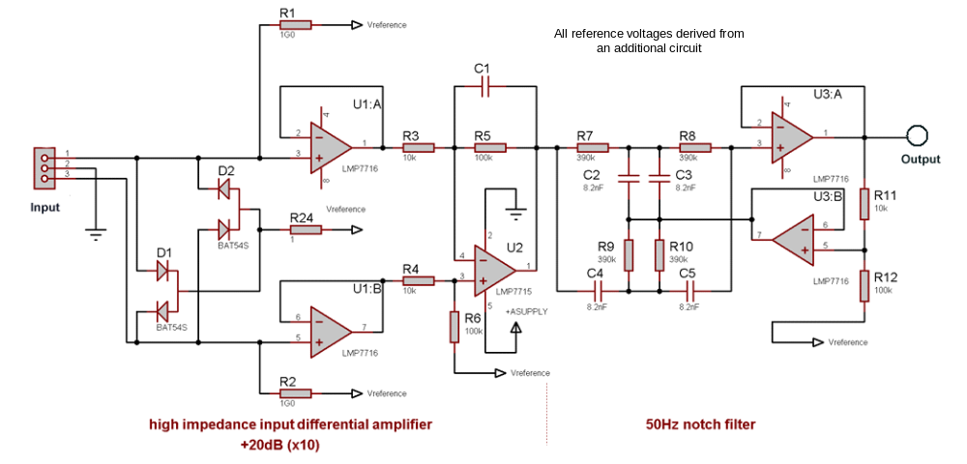

Figure 4.3 Typical VLF Amplifier for use with a Ferrite rod Antenna

- Performance
The antenna described is capable of a 30 to 40dB signal (to referred amplifier noise) ratio. This is adequate for coping with the dynamic range of signals from VLF transmitters. The performance can be optimised over the frequency band by tuning with a small 1nF low loss capacitor.

In this example we have chosen to have the maximum sensitivity at the higher end of the band to receive DHO from Germany (23.4kHz) and NAA from the USA on 24.0kHz. The resonant frequency is given by the well known formula:

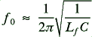

Where f₀ = resonant frequency in Hz
L_{f} = Inductance of the coil on the ferrite rod
C = The total capacitance ( self capacitance + tuning capacitance)
For the 200mm rod, L=42.5mH, C = 1.2nF and f₀ = 22.3kHz

An example of the signal to noise ratio achievable for typical VLF stations can be seen in the spectrum in Figure 5.1.

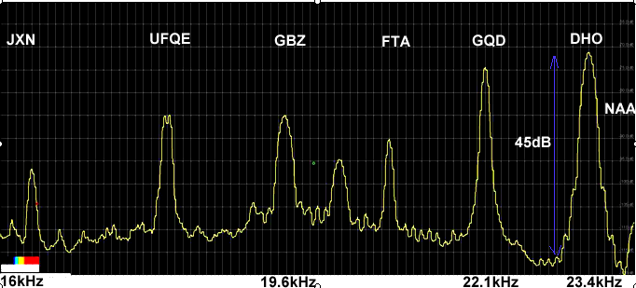

Frequency kHz

Figure 5.1 Typical signal levels above noise for VLF stations

The orientation of the rod antenna is set for good reception of DHO (23.4 kHz). The signal from NAA (24.0 kHz) located on the Eastern seaboard of the USA can be seen at the extreme right of the spectrum. Due to the ability of Spectrum Lab to select the amplitude of signals with a bandwidth precision of ~ 10Hz the signal strength of NAA can also be logged without a problem. (The antenna orientation is not optimum for NAA in this spectrum).
- Digital Spectrum Analysis
The Spectrum Lab software can be used to filter and display the signal strength of up to 20 VLF stations simultaneously. The filter bands for each station are individually set and the sample rate can be 10ms to minutes.

The ‘Watch List’ function can be used to produce a ‘strip chart’ record of signal strengths of all selected VLF stations over an entire day or week etc.

The strip chart can plot maximum, minimum or average signals (or all three if required) for each station being monitored. There is a scrolling ‘strip chart’ display and the data can also be exported as a text file at any time.
See Figure 6.1

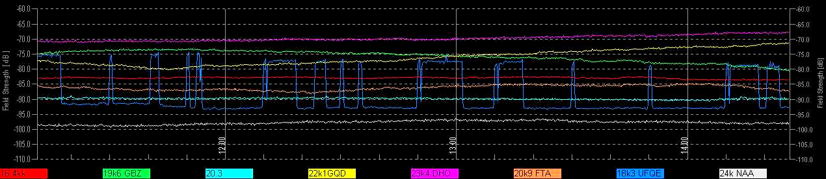

Figure 6.1 The ‘Watch List’ screen showing
signal strength recordings of 8 VLF stations

It is not the purpose of this paper to explain in detail the many useful features of the Spectrum Lab software, but a few of them are of special use in producing high quality measurements.

- Digital filtering
A range of digital filters are available that can be used to correct for the frequency response of the receiver (largely that of the antenna) to give a flat noise baseline over the frequency band of interest.
The filter can also be used to remove most of the low frequency mains related signals and noise from domestic electric motors up to 10kHz. This results in a clean band-limited signal to be analysed.

- Noise blanker
This function is also software configured and can be used to remove transient signals from the records. It is particularly useful in removing – or minimising - the interference from electric fences and other legal, but noisy equipment that may not be detectable by ordinary AM radios but interfere significantly with reception in the VLF band.

- Watch List
This can be used to record the signal strength of up to 20 signals with a setting resolution of about 10Hz. The peak of any VLF signal can be recorded without ‘contamination’ from adjacent signals via leakage through filter skirts, which can be a problem using standard multi-pole electrical filters. Each nominated channel (record) can have software conditions applied to it, eg conditional actions can be set if the signal exceeds or falls below a certain level etc.

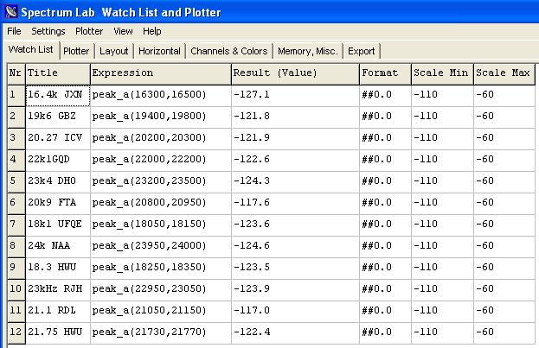

Figure 6.2 Spectrum Lab Watch List
configuration window

Format plot scales

Measured peak signal level within set frequency bounds

Set the measurement of the peak signal levels within frequency limits

Trace identifier – name of VLF station being monitored

The above illustrates how to set up a station signal level monitoring list to give a display as shown in Figure 6.1.
- Using the System
7.1 Packaging and Location
The antenna can be built into a 220mm long x 40mm diameter plastic pipe with sealed ends. Screened twin conductor coaxial cable is used to connect the antenna coil to the preamplifier. The length of this cable should be a minimum to keep the coil loading capacitance down, as this would limit the tuning range with an external capacitor. Around 100mm long is fine.

The preamplifier is normally built in an aluminium die-cast box and housed in a waterproof plastic container. The antenna and preamplifier could be housed in the same container if required.

The receiver unit is best located away from buildings containing mains wiring and other electrical items to minimise interference. However with the broad band high pass filtering in the spectrum analyser, interference does not significantly affect the measurement of VLF station signal strengths. This is providing that the peak level of interference does not clip the amplifier or the sound card in the computer. If this proviso is met the antenna can easily be used in a normal house and sensible readings obtained.

7.2 VLF Stations to be Monitored
With the ability of this system to monitor up to 20 different signals, some consideration needs to be given to which transmitters to monitor. This will depend on the location of the receiver and distance to the transmitter. Ideally the distance should be 300km or more so that the received signal strength is dependent on the reflection from the D region in the ionosphere.

It is variation in the ionisation of the D region and its height above ground that alters the reflection geometry when an X ray burst impacts the earth resulting in a SID.

Figure 7.1 shows the reflection geometry. The height h = 90km and the distance D ~ 300km

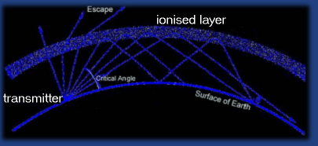
Receiver
h
D

Figure 7.1 Reflection of a Radio Signal from the D region.

The VLF stations chosen for regular monitoring by the author are as follows:

Call Sign Country Frequency
JXN Norway 16.4kHz
UFQE Russia 18.1kHz
HWU France 18.3kHz
GBZ UK 19.6 kHz
ICV Italy 20.27kHz
FTA France 20.9kHz
RDL FSU 21.1kHz
GQD UK 22.1kHz
RJH Russia 23.0kHz
DHO Germany 23.4kHz
NAA USA 24.0kHz

The benefit of monitoring several stations simultaneously is that the effect of the SID can be seen at different frequencies – but at the same time! This enables the analyst to discriminate between genuine SIDs and other effects or interference. This can be seen in Figure 7.2 where the classic ‘Shark fin’ shape is seen clearly on the GQD, DHO, NAA, HWU and FTA traces, with smaller responses on the GBZ and ICV records.

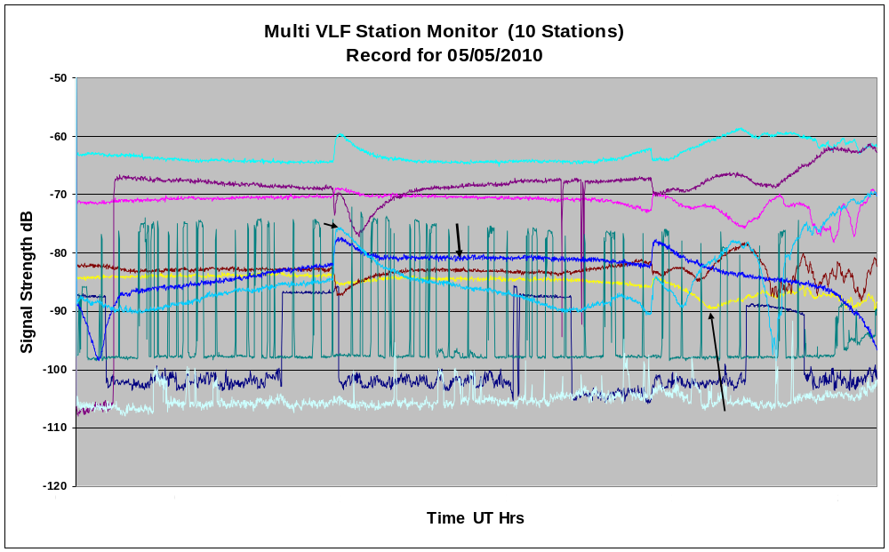

Figure 7.2 Multi VLF station record with two SID events.

The details of the SIDs can be taken from these records using Microsoft EXCEL, for example, to produce the final graph shown in Figure 7.3.The causal Solar X ray bursts are shown in Figure 7.4
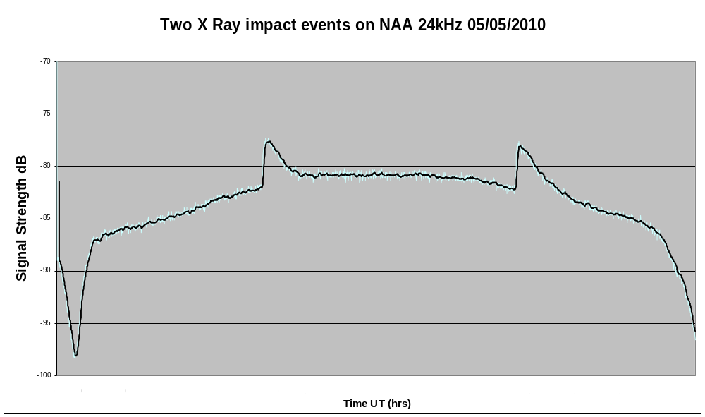

Figure 7.3 Two SID events
on 5/5/2010
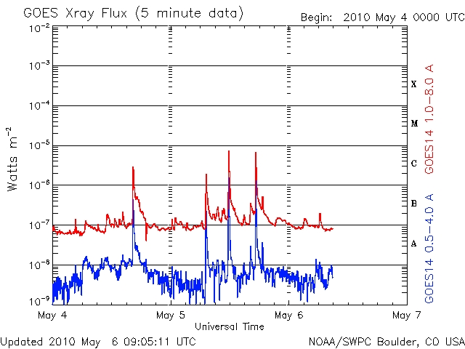

Figure 7.4 GOES Satellite data showing Solar X ray bursts

- Conclusion

A standard, easily available AM radio ferrite rod antenna (120mm long) can be used with a simple amplifier to produce a very compact VLF receiver capable of measuring variations in the signal strength of VLF transmitting stations. Monitoring these signals can show the advent of Sudden Ionospheric Disturbances (SIDs) caused by Solar X ray bursts.

It has been also been shown that an enhanced 200mm long Ferrite Rod based antenna can be constructed with improved sensitivity (signal to noise ratio) that results in a compact VLF receiver capable of monitoring 12 or more transmitters from around the world. SIDs can be observed on many frequencies simultaneously and large amplitude diurnal signal strength changes can be seen down to low levels.

The receiver is small enough to be easily packaged and water-proofed for permanent location outside, or can be used in most settings in a normal house providing care is taken not to overload the amplifier with interference.

A dozen or more VLF stations can be monitored with precision using digital filters configured in the Spectrum Lab software analysis programme. Automatic strip charts of the signal strength of these stations can be produced over days or weeks and saved for analysis as text files.

SIDs can be identified as occurring on a number of VLF transmitter frequencies at the same time, making it easier to identify genuine Ionospheric events and discriminate other effects and interference.

